Facial Emotion Recognition Using Machine Learning, Deep Learning, and Computer Vision
Mid-Project Report (Milestone 2)
Group members: Mugheeza , Kainat Ashraf , Wardah Amir
Supervisor: Sir Aqib Mehdi

Abstract
This report presents the work completed for Milestone 2 of our Facial Emotion Recognition project. Using the FER-2013 dataset, we explored and preprocessed the data, trained three classical Machine Learning models on HOG features (SVM, KNN and Random Forest), trained a Convolutional Neural Network (CNN), and built a working Computer Vision pipeline that detects a face in a photo and predicts its emotion. On the 7,178 test images, the CNN reached 60.66% accuracy, while the best classical model (HOG + SVM) reached 47.84%. The report describes the data, methods, results, problems encountered and planned improvements.

1. Introduction
Facial expressions carry important information about a person's emotional state. Identifying emotions manually becomes slow and difficult when there are many images or a live video stream. The aim of this project is to build a system that automatically detects a face and classifies its expression into one of seven emotions: Angry, Disgust, Fear, Happy, Sad, Surprise and Neutral.
The project studies three approaches on the same problem: Machine Learning (ML), Deep Learning (DL) and Computer Vision (CV). Its objectives are:
- Preprocess and prepare the FER-2013 dataset for ML and DL experiments.
- Extract HOG features and compare SVM, KNN and Random Forest classifiers.
- Train a CNN directly on the images for automatic emotion classification.
- Detect faces with OpenCV and join all parts in one working pipeline.
- Compare all models using accuracy, precision, recall, F1-score and confusion matrices.
The proposal set two accuracy targets: at least 45% for the ML models and at least 60% for the CNN. Both targets were met at this stage.

2. Dataset and Data Exploration
We use the FER-2013 (Facial Expression Recognition 2013) dataset from Kaggle. It contains 35,887 grayscale face images of 48 × 48 pixels, arranged in a training folder (28,709 images) and a testing folder (7,178 images), with one sub-folder per emotion.
The training set is clearly unbalanced, as the table below shows. Happy has the most images, while Disgust has only 436, about 1.5% of the training data.
Emotion | Training images
Angry | 3,995
Disgust | 436
Fear | 4,097
Happy | 7,215
Neutral | 4,965
Sad | 4,830
Surprise | 3,171
Total | 28,709
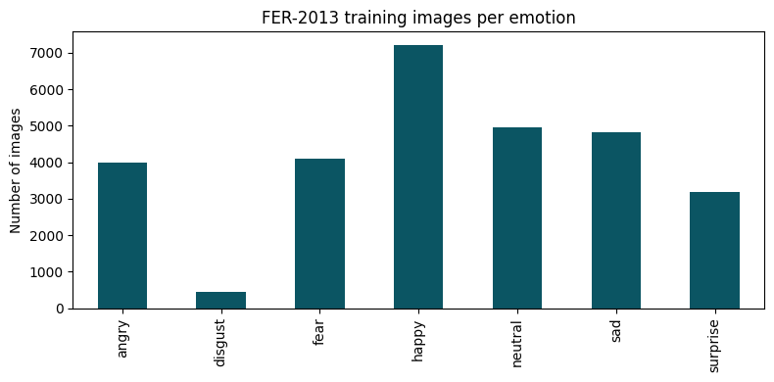
Figure 1: Number of training images per emotion. Disgust is much smaller than the other classes.

3. Preprocessing
The same preprocessing and data split were used in the ML and DL notebooks, so the models can be compared fairly.
- Images are read in grayscale and checked to be 48 × 48 pixels.
- Pixel values are scaled from 0–255 to 0–1.
- Emotion names are encoded as numbers 0–6 (alphabetical order).
- 15% of the training data is held out as a validation set using a stratified split (random state 42). This gives 24,402 training, 4,307 validation and 7,178 test images.
- For the CNN, data augmentation (horizontal flip, small rotation and zoom) is applied during training only.

4. Methodology

4.1 Machine Learning:
Each image is converted into a Histogram of Oriented Gradients (HOG) feature vector (9 orientations, 6 × 6 pixel cells, 2 × 2 cell blocks), which gives 1,764 features per image. Three classifiers were trained on these features:
- SVM: RBF kernel with C = 10, trained on a subset of 8,000 training images to keep training time low.
- KNN: 5 neighbours, trained on all 24,402 training images.
- Random Forest: 200 trees, trained on all 24,402 training images.

4.2 Deep Learning:
The CNN takes a 48 × 48 grayscale image and has three convolution blocks (32, 64 and 128 filters). Each block has two convolution layers with batch normalization and ReLU, followed by max pooling and 25% dropout. These are followed by a dense layer of 256 units with batch normalization and 50% dropout, and a softmax output of 7 classes. The model has about 1.47 million parameters. It was trained with the Adam optimizer (learning rate 0.001, batch size 64) for 15 epochs, with learning-rate reduction when the validation loss stopped improving.

4.3 Computer Vision:
The pipeline uses the OpenCV Haar Cascade frontal face detector. For each photo it finds the face, keeps the largest detected face, crops it, converts it to 48 × 48 grayscale (the same format as FER-2013), and passes it to the trained CNN. The predicted emotion and its confidence are drawn on the image. As a comparison, the pretrained DeepFace model was also run on the same cropped faces.

5. Results

5.1 Model comparison on the test set
All models were evaluated on the same 7,178 test images. Precision, recall and F1 are macro averages over the seven classes.
Model | Accuracy | Precision | Recall | F1-score | Training time
HOG + SVM (8,000 images) | 47.84% | 53.79% | 42.40% | 44.53% | 150.7 s
HOG + KNN | 46.06% | 44.49% | 42.16% | 42.20% | under 1 s
HOG + Random Forest | 45.08% | 56.03% | 38.67% | 41.04% | 277.9 s
CNN | 60.66% | 62.18% | 51.92% | 52.48% | not recorded
The CNN is almost 13 percentage points more accurate than the best classical model. The three classical models are close to each other (45% to 48%).

5.2 Results per emotion (F1-score)
Emotion | HOG + SVM | HOG + KNN | HOG + RF | CNN
Angry | 0.36 | 0.37 | 0.25 | 0.52
Disgust | 0.35 | 0.34 | 0.41 | 0.19
Fear | 0.32 | 0.34 | 0.30 | 0.33
Happy | 0.67 | 0.61 | 0.58 | 0.82
Neutral | 0.43 | 0.42 | 0.42 | 0.56
Sad | 0.37 | 0.31 | 0.31 | 0.51
Surprise | 0.61 | 0.57 | 0.59 | 0.74
For the CNN, the detailed test results per class were:
Emotion | Precision | Recall | F1-score | Test images
Angry | 0.50 | 0.55 | 0.52 | 958
Disgust | 0.80 | 0.11 | 0.19 | 111
Fear | 0.50 | 0.24 | 0.33 | 1,024
Happy | 0.78 | 0.88 | 0.82 | 1,774
Neutral | 0.55 | 0.58 | 0.56 | 1,233
Sad | 0.46 | 0.56 | 0.51 | 1,247
Surprise | 0.77 | 0.71 | 0.74 | 831
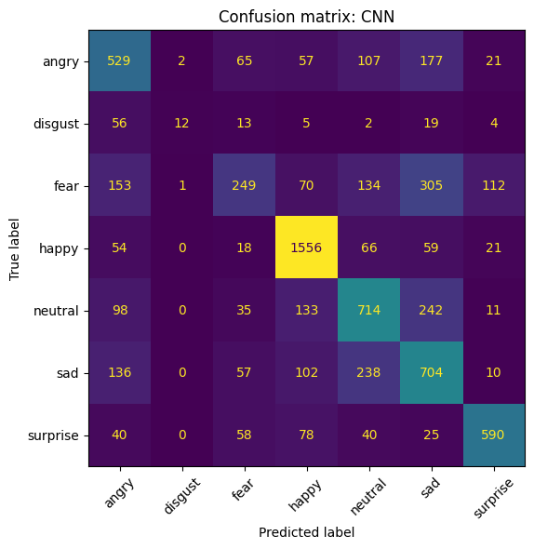
Figure 2: Confusion matrix of the CNN on the test set.

5.3 CNN training
Over the 15 epochs, validation accuracy rose from 31.2% to 61.6% and validation loss fell from 1.745 to 1.038. The final test accuracy (60.66%) is close to the final validation accuracy (61.6%), which suggests the model generalizes to unseen images at this stage. Accuracy was still improving at epoch 15, so longer training is likely to help.
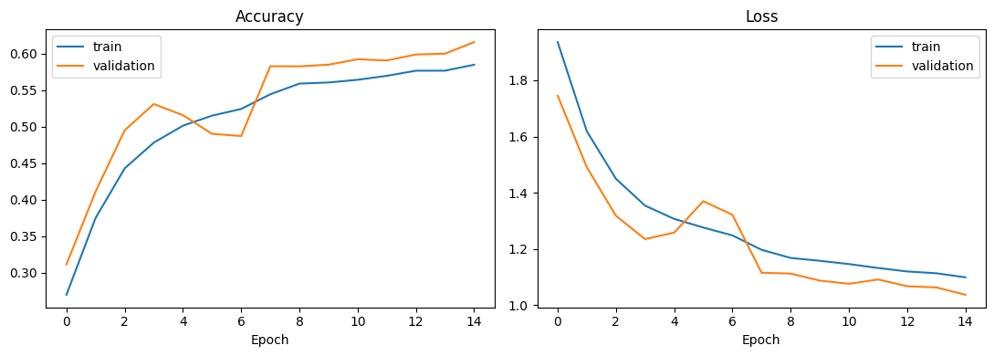
Figure 3: CNN training and validation accuracy (left) and loss (right) over 15 epochs.

5.4 Working prototype
We tested the full pipeline on five clear photos taken from Pexels (free licence). Expected emotions are based on our own reading of each face, so this is only a small demonstration and not a measure of accuracy.
Photo | Expected emotion | Our CNN | DeepFace
Smiling child | Happy | Happy | Happy
Man with head on hand | Sad | Sad | Fear
Woman with open mouth and wide eyes | Surprise | Sad | Fear
Shouting man | Angry | Angry | Angry
Frowning girl | Angry | Angry | Angry
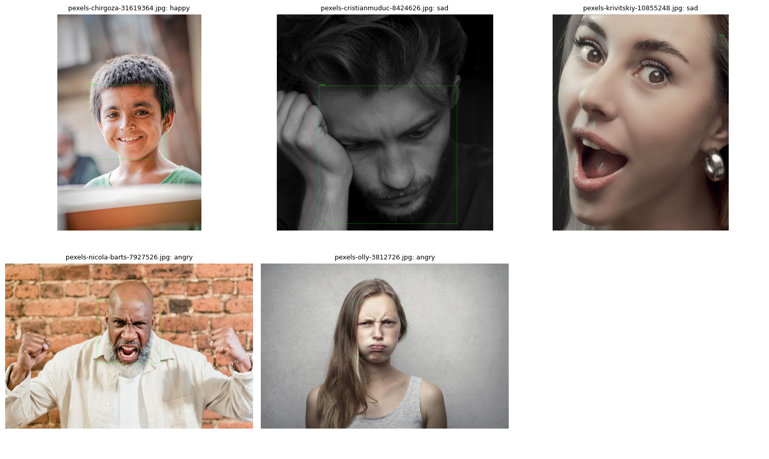
Figure 4: Output of the working pipeline on the five test photos (green box = detected face, title = predicted emotion).
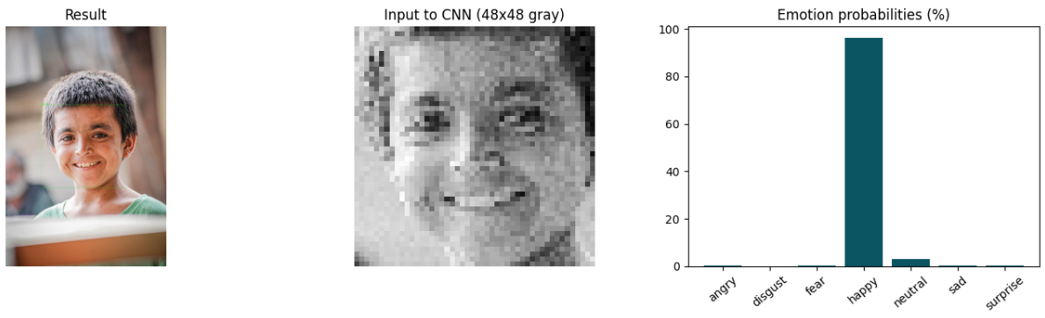
Figure 5: Detail for one photo: the result, the 48 × 48 grayscale face given to the CNN, and the probability of each emotion (Happy is over 90%).
Our CNN gave the expected emotion for 4 of the 5 photos and DeepFace for 3 of 5. Neither model recognized the surprised face.

6. Discussion
- CNN versus classical ML. The CNN learns its own features from the pixels and is clearly better than HOG with SVM, KNN or Random Forest on almost every emotion.
- Easy and hard emotions. Happy and Surprise are recognized best by all models. Fear, Sad and Angry are often confused with each other, which is common on FER-2013 because the images are small and the labels are noisy.
- Disgust. Disgust has very few training images. The CNN rarely predicts it (recall 0.11), although it is usually right when it does (precision 0.80). The classical models do better on Disgust, but their numbers come from only 111 test images and should be read with care.
- Limits of the prototype. Only five photos were tested, so the 4 of 5 result shows that the pipeline works but does not estimate the real accuracy. The test-set results in Section 5.1 are the reliable measure.

7. Problems Encountered
- Class imbalance. Disgust has only 436 training images, so it is poorly recognized.
- Face detection. The first detector settings produced extra false faces in some photos. We now keep only the largest detected face. Close-up faces can still be missed with strict settings, so the settings need a balance.
- Similar emotions. Fear, Sad, Angry and Surprise are often confused.
- Training time. The SVM was trained on 8,000 images only, and the Random Forest took about 4.6 minutes.
- Tools. Some Colab sessions had to be restarted and notebooks re-run, so results were saved as soon as they were produced.

8. Planned Improvements
- Build the emotion recognition application where a user gives a photo and receives the predicted emotion.
- Extend the pipeline to video or webcam frames.
- Improve the CNN with more epochs, parameter tuning, and class weights to help Disgust.
- Train the SVM on all training images and tune the ML models.
- Test face detection on a larger set of photos and report the detection rate.
- Compare all models again and prepare the final report.

9. Division of Work
Member | Area | Work completed
Mugheeza | Machine Learning | Data exploration, preprocessing, HOG features, SVM, KNN, Random Forest, evaluation
Kainat Ashraf | Deep Learning | CNN design, training, evaluation, saved model
Wardah Amir | Computer Vision | OpenCV face detection, 48 × 48 preprocessing, pipeline with the CNN, DeepFace comparison

10. Conclusion
At Milestone 2, the project has a working prototype with all parts in place: the dataset is explored and preprocessed, four models are trained and evaluated with the same metrics, and a pipeline can detect a face and predict its emotion from a photo. The CNN (60.66%) clearly outperforms the classical ML models (45% to 48%). The next stage is to improve the models, handle the weak Disgust class, and add the application and video demo.

References
- FER-2013 dataset, Kaggle: https://www.kaggle.com/datasets/msambare/fer2013
- Khaireddin, Y. and Chen, Z. (2021). Facial Emotion Recognition: State of the Art Performance on FER2013. arXiv:2105.03588. https://arxiv.org/abs/2105.03588
- Goodfellow, I. et al. (2013). Challenges in Representation Learning: A report on three machine learning contests. arXiv:1307.0414. https://arxiv.org/abs/1307.0414
- OpenCV library, Haar Cascade face detector: https://opencv.org
- Test photos: Pexels (https://www.pexels.com), free licence.

